

Drama of a referendum
The following sequence of activities is designed to evaluate the role of citizens in shaping Australia’s democratic nation.
Process drama is a dramatic form that engages a variety of students and encourages students to think critically and creatively; to analyse and generate ideas. The following sequence of activities works best when the process is followed. However, activities can be adjusted to suit the needs of learners. Teachers can pause the process at any point to reflect and discuss.
Helpful resources
Images of significant individuals or groups within Federation (e.g. the Queen, Henry Parkes, merchants, transport workers, migrants, politicians, Governer-General, children).
Activity | Purpose | Students will:
Pretext | Explore the different groups in Australian society in the lead-up to Federation. | design frozen ‘statues’ for each group of people — consider statues relevant to their opinion of Federation (discourage stereotypes).
Warm-up | Engage students in role-play of significant individuals and groups within Australian history. | play musical statues using roles. Use colonial music where possible.
Stimulus | Read the for and against arguments for Federation. | read arguments and information.
Gossip mill | Develop arguments for or against Federation. | wander around the ‘town square’ in role, gossiping about the upcoming referendum and their perspective on the issue.
Protest slogans | Collaborate to present viewpoints. | split into for Federation (Billites) and against Federation (anti-Billites). They develop slogans to protest.
Re-enactment of a protest scene | Empathise with people in history who fought for and against change in Australian history and/or future. | divide the classroom and role-play a protest scene.
Reflection | Reflect on learning through discussion. | use questions to guide reflective conversations in class.

Questions
Why is the process of a referendum important for making change?
What role do the public play in changing history or the future?
How do referendums link to democracy?

Stimulus: Thoughts on the Constitution

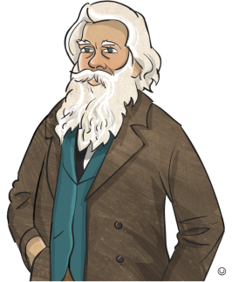



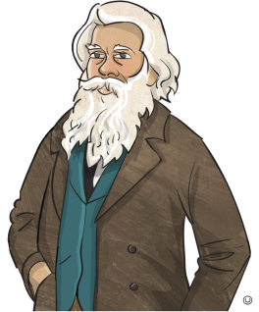
Australia’s system of law and government is set out in one of the country’s most important legal documents, the Constitution. The Constitution can be considered the ‘birth certificate of the nation’ because it sets out the rules for the way that our government must operate and how laws are made.
Why bother? It is far too complicated and is expensive.
Federation will unite Australia. It will connect us all and build a stronger future for all.

My dad says it will protect employment and improve immigration laws.
But we are a small colony — it’s not fair that we have to be like NSW.
South Australia is changing lives for women. Why should we move backwards and join the colonies who don’t respect our rights?
But you have to consider all the positives — defence, trade, transport, customs, border control — Federation is crucial for our future!

The first draft of Australia’s Constitution was produced at the National Australasian Federation Convention in Sydney in 1891. Referendums were held in the Australian colonies to vote ‘yes’ or ‘no’ to the proposed Constitution.
The Constitution can only be changed by a referendum, which is a complicated process requiring the people of Australia to vote yes or no to proposed changes. In fact, since Federation, Australians have only agreed to eight changes to the Constitution.

